**Name:- B. Nageswar**

**Reg-No**: 192372005

3 Design a CPU scheduling program with C using First Come First Served technique with the following considerations.

a. All processes are activated at time 0.

b. Assume that no process waits on I/O devices.

**Aim:**

To design a program to simulate the **First Come First Serve (FCFS)** CPU scheduling algorithm, considering all processes are activated at time 0 and no I/O wait.

**Algorithm:**

1. Input the number of processes and their burst times.
2. Compute the completion time (CT) for each process.
   * CT[i]=CT[i−1]+BT[i]CT[i] = CT[i-1] + BT[i]CT[i]=CT[i−1]+BT[i] for i≥1i \geq 1i≥1.
3. Calculate Turnaround Time (TAT) and Waiting Time (WT):
   * TAT=CT−ArrivalTimeTAT = CT - ArrivalTimeTAT=CT−ArrivalTime
   * WT=TAT−BTWT = TAT - BTWT=TAT−BT
4. Display results including Completion Time, Turnaround Time, and Waiting Time.

**Procedure:**

1. Input process details (arrival times are 0 by default).
2. Iterate through processes in the order of arrival.
3. Use the FCFS formula to calculate the required times.
4. Output the computed metrics.

**Code:**

### #include <stdio.h>

### int main() {

### int n, i;

### printf("Enter the number of processes: ");

### scanf("%d", &n);

### int bt[n], ct[n], tat[n], wt[n];

### printf("Enter burst times: ");

### for (i = 0; i < n; i++) {

### scanf("%d", &bt[i]);

### }

### ct[0] = bt[0];

### for (i = 1; i < n; i++) {

### ct[i] = ct[i - 1] + bt[i];

### }

### for (i = 0; i < n; i++) {

### tat[i] = ct[i];

### wt[i] = tat[i] - bt[i];

### }

### printf("\nProcess\tBurst Time\tCompletion Time\tTurnaround Time\tWaiting Time\n");

### for (i = 0; i < n; i++) {

### printf("%d\t%d\t\t%d\t\t%d\t\t%d\n", i + 1, bt[i], ct[i], tat[i], wt[i]);

### }

### return 0;

### }

### ****Result****

This simple implementation calculates the Completion Time (CT), Turnaround Time (TAT), and Waiting Time (WT) for all processes following FCFS scheduling.

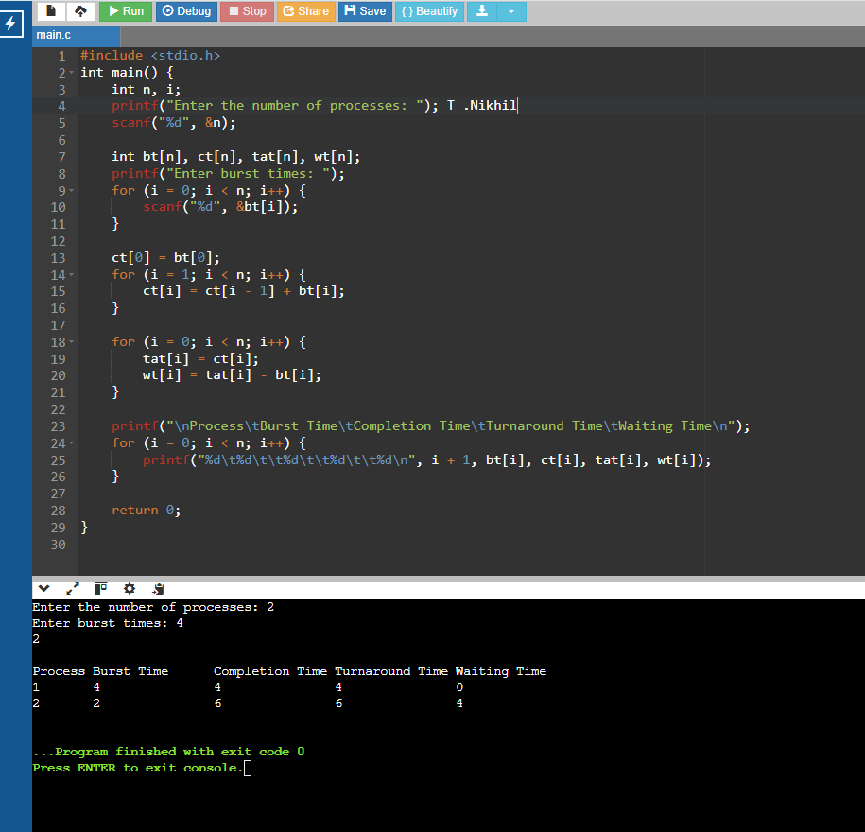**Output:**